

**KINGSWAY CHRISTIAN COLLEGE**

**Year 12 ATAR Physics 2017**

**Task 7**

**In class response to Quantum Theory article**

Name _____***An Swerkey***_

Date due: ***Wednesday, 02 August 2017***

**Time allowed 40 minutes**

|  |  |  |
| --- | --- | --- |
|  | **Available mark** | **Student mark** |
| 1 | 2 |  |
| 2 | 2 |  |
| 3 | 2 |  |
| 4 | 2 |  |
| 5 | 5 |  |
| 6 | 4 |  |
| 7 | 4 |  |
| 8 | 19 |  |
| ***Total marks*** | ***40*** |  |
| ***%*** | ***100*** |  |

NORTHERN LIGHTS

The northern lights could be mistaken for an iridescent green mist until they dance across the sky, dipping and pirouetting, swirling like a tornado, or hanging like curtains rippling in breeze.

The Sun powers the performance via a stream of electrons and protons known as the solar wind that buffets atoms in the Earth’s atmosphere, causing them to release photons of light. The reason for the green colour is twofold. At an altitude of between 100 and 200 kilometres, nitrogen molecules are outnumbered by oxygen atoms, which are split from their molecular form by ultraviolet light. When buffeted by the solar wind, oxygen atoms glow green, a colour to which our eyes are more sensitive than the blue-violet glow of nitrogen molecules.

This dance was performed in Finish Lapland, just inside the Arctic Circle.

HALO

The fierce solar wind bumps other charged particles trapped in Earth’s magnetic field and sends them racing along the magnetic field lines to both poles. At the North Pole the display goes by the name *aurora borealis*: at the South Pole it’s the *aurora australis*.

The solar wind normally blows at around 400 km.s−1 but explosions on the Sun’s surface known as coronal mass ejections create blizzards of 1000 km.s−1 and dramatic auroras. On 11 September 2005, NASA’s IMAGE satellite captured a brilliant *aurora australis* created by one such storm.

JUPITER

The best place in the solar system to see auroras is Jupiter where they are thousands of times brighter than those on Earth.

Here Jupiter’s auroras are captured by NASA’s Chandra X-ray space telescope. The Image is overlaid on a Hubble photograph of the gas giant.

Unlike Earth’s intermittent displays, Jupiter’s aurora permanently lights up its skies because, beside the Sun, the moon Io gets into the act. Io’s volcanic eruptions spit jets of charged particles into space. They are captured by Jupiter’s magnetic field and catapulted toward the planet’s poles to create a never-ending show.

SATURN

The Cassini space probe allowed us to see Saturn’s brilliant aurora.

Just as on Earth, it flares brightest when buffeted by solar storms. Cassini captured this powerful aurora 1000 kilometres above the cloud tops around Saturn’s South Pole.

Earth’s atmosphere is rich in oxygen and nitrogen but Saturn’s is mainly composed of hydrogen, which gives off strong ultra-violet emissions when excited. But the excited hydrogen does give off a little visible light too. Cassini’s spectrometers captured some of this light in this image. The green colouring is artificial. If it were possible to stand at Saturn’s poles you’d see faint pink-red ripples dancing across the sky.  
*From an article in COSMOS Issue 68 April-May 2016.*  
  
The emission spectra of the elements Nitrogen, Oxygen and Hydrogen are also given below.

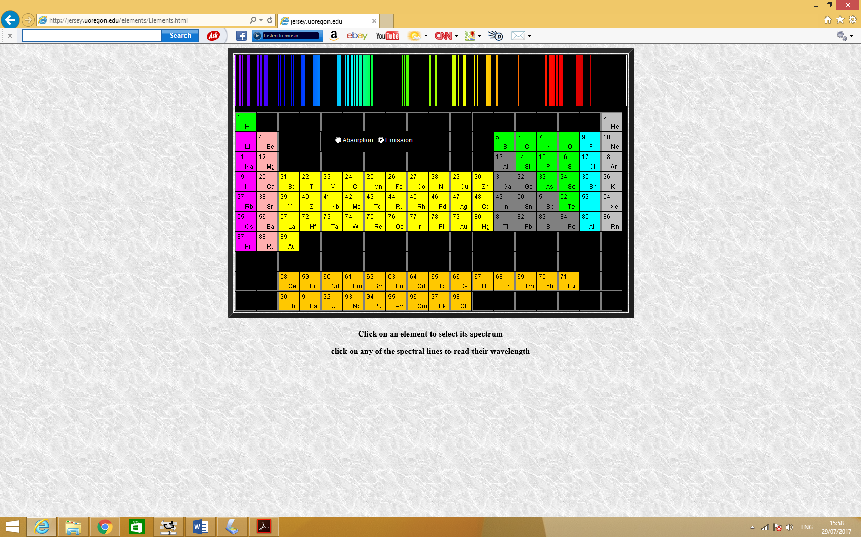

***Emission Spectrum of Nitrogen***

**400nm 500nm 600nm 700nm**

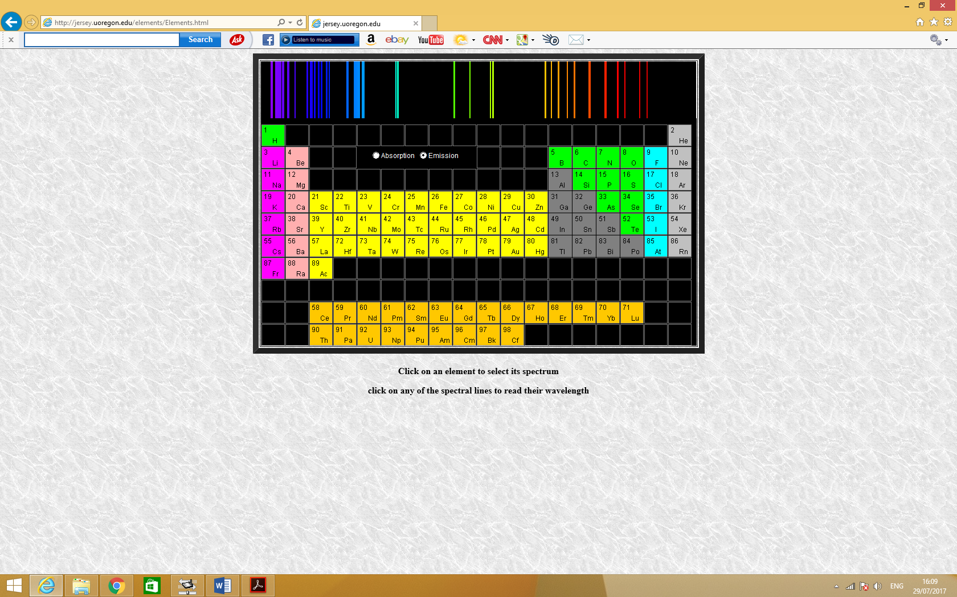

***Emission Spectrum of Oxygen***

**400nm 500nm 600nm 700nm**

**400nm 500nm 600nm 700nm**

***Emission Spectrum of Hydrogen***

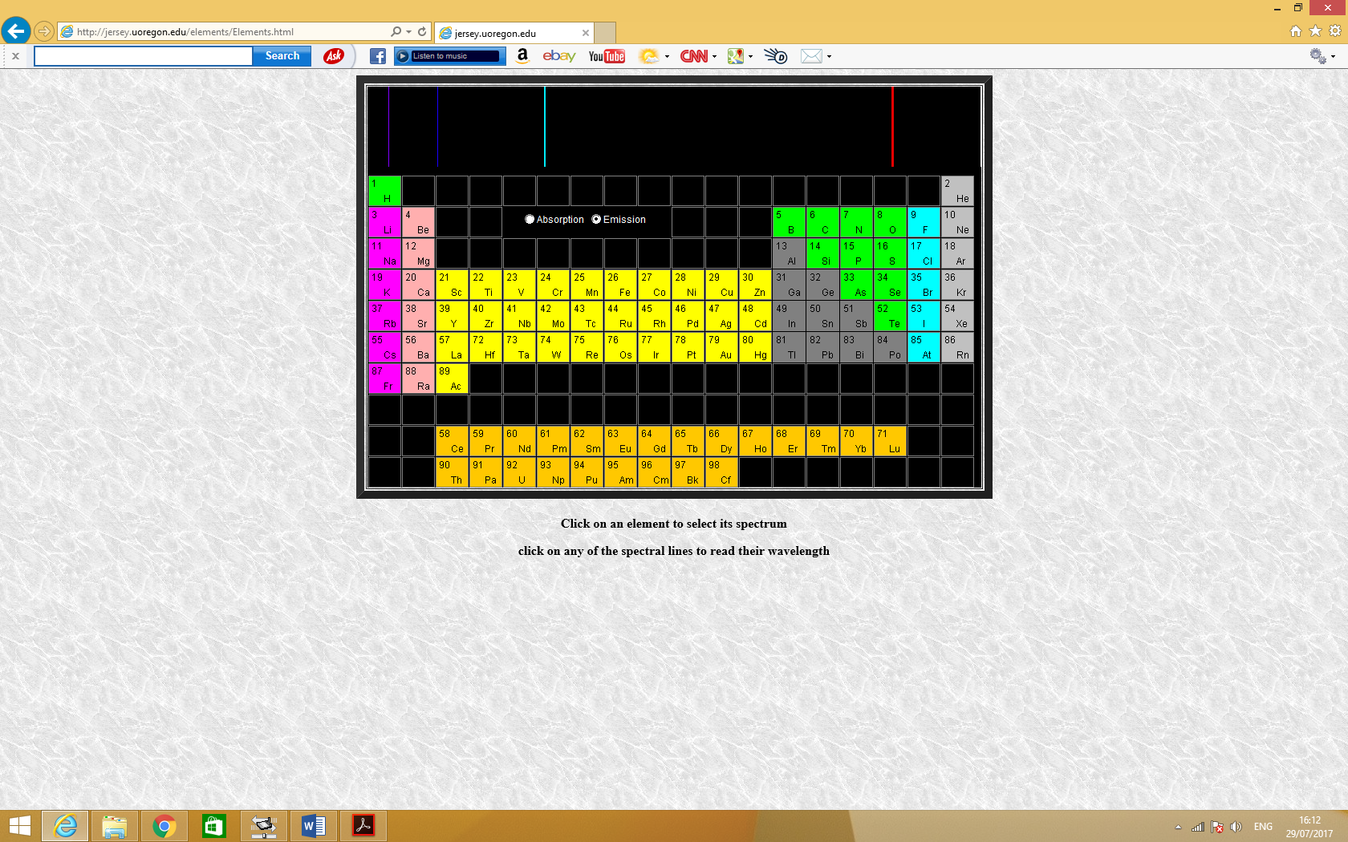

1. What charged particles are contained in the solar wind? [2]

***Protons and electrons ***

2. At what altitude(s) does interaction between solar wind and atmospheric particles that result in auroras generally occur? [2]

***100 km to 200 km above the Earth’s surface ***

3. What is the make-up of particles in the Earth’s atmosphere at the altitude(s) mentioned in question 2? [2]

***Nitrogen molecules and oxygen atoms ***

4. Why is green the predominant colour of the auroras formed in question 2? [2]

***More oxygen atoms than nitrogen molecules. Excited oxygen atoms glow green.***

***Our eyes are more sensitive to green colour (Middle of visible spectrum)***

***Excited nitrogen molecules produce blue-violet glow.***

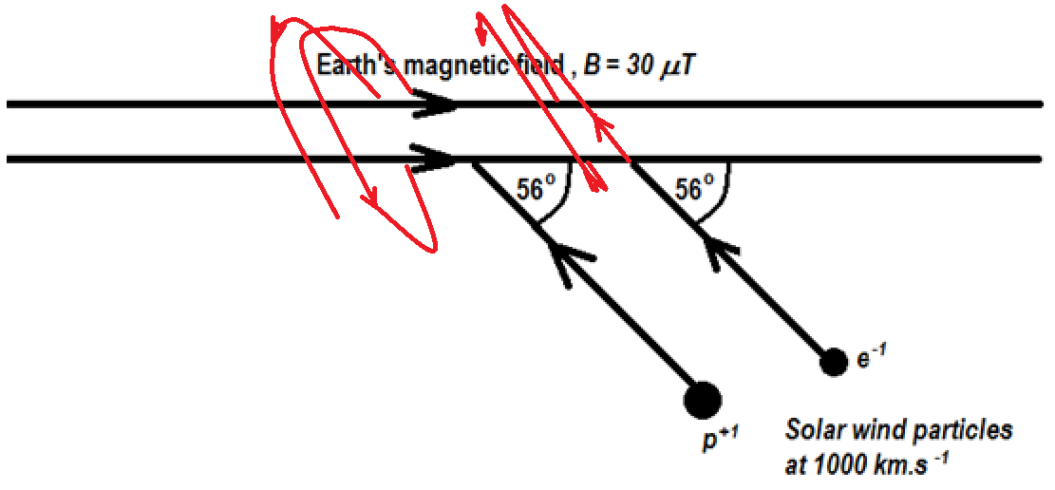5. At a location high up in the atmosphere, the magnetic field intensity of the Earth is uniform and has a magnitude of 30 μT and is directed as shown. Two solar wind particles are shown, a proton and an electron both approaching the Earth’s magnetic field at 56o and each with a speed of 1000 km.s−1.  
Describe the subsequent movement of these particles and carefully explain whether they will result in the formation of ***aurora borealis*** or ***aurora australis***. [5]

***Both particles’ velocities can be resolved into two components. 1000 cos56 km.s−1 parallel to but opposite to the Earth’s magnetic field B; the other 1000 sin 56 km.s−1 perpendicular to the Earth’s***

***Magnetic field B. The parallel component will move both particles along towards the South Pole. The perpendicular components will result in uniform circular motion.  
The proton when viewed from the right side of the diagram will go into an anticlockwise spiral motion towards the South Pole and the electron will go into a clockwise spiral towards the South Pole. Both will end up forming aurora australis.***

6. The visible spectrum has photons with wavelengths ranging between 400 nm and 800 nm. What is the minimum speed of a solar wind electron that excite atmospheric atoms so they are able to emit almost any colour in the visible spectrum? [4]

***The electron needs to have a kinetic energy at least equal to that of a 400 nm photon.***

$$E=\frac{hc}{}= \frac{6.63 10^{-34} 3 10^{8}}{400 10^{-9}}=4.9725 10^{-19}J$$

$$\frac{1}{2}mv^{2}=E \\ v= \sqrt{\frac{2E}{m}}=\sqrt{\frac{2 4.9725 10^{-19}}{9.11 10^{-31}}}=1.04 10^{6} m.s^{-1}$$

*(Correctly evaluate E with corking out ; relating E to Ek ; finding v )*

7. Explain how the charged particles from Io’s volcanic eruptions get captured and help produce the permanent aurora show on Jupiter. [4]

***Jupiter’s gravitational field attracts them and they are unable to escape the gravitational field.***

***They are charged particles and their movement constitute a current.***

***As they cross the magnetic field of Jupiter, they are sent into a spiral motion depending on their angle of approach to either the South or North Pole.  
As the spiral along, they collide with the atmospheric gas particles of the gas giant causing these atmospheric particles to become excited.  
As they de-excite, they produce the photons which if visible form the aurora show.***

8. The energy levels in a hydrogen atom are given by the equation $$E_{n}= -\frac{13.6 eV}{n^{2}} where n is an integer called a quantum number. \\ n=1 is the ground state and n= ∞ is ionisation$$

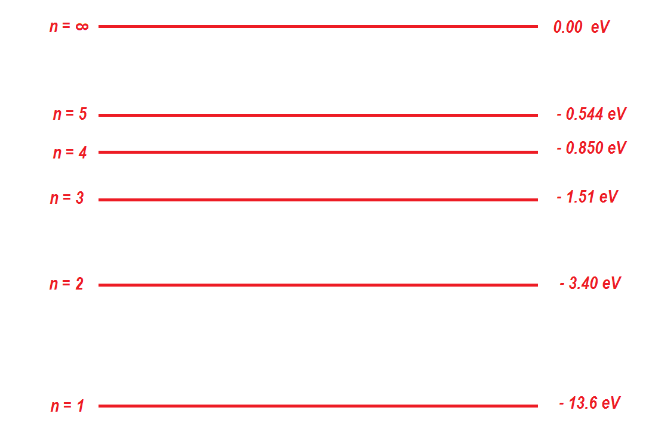a) Draw an energy level diagram for a hydrogen atom showing the energies for   
n = 1, 2, 3, 4, 5 and ∞. [7]

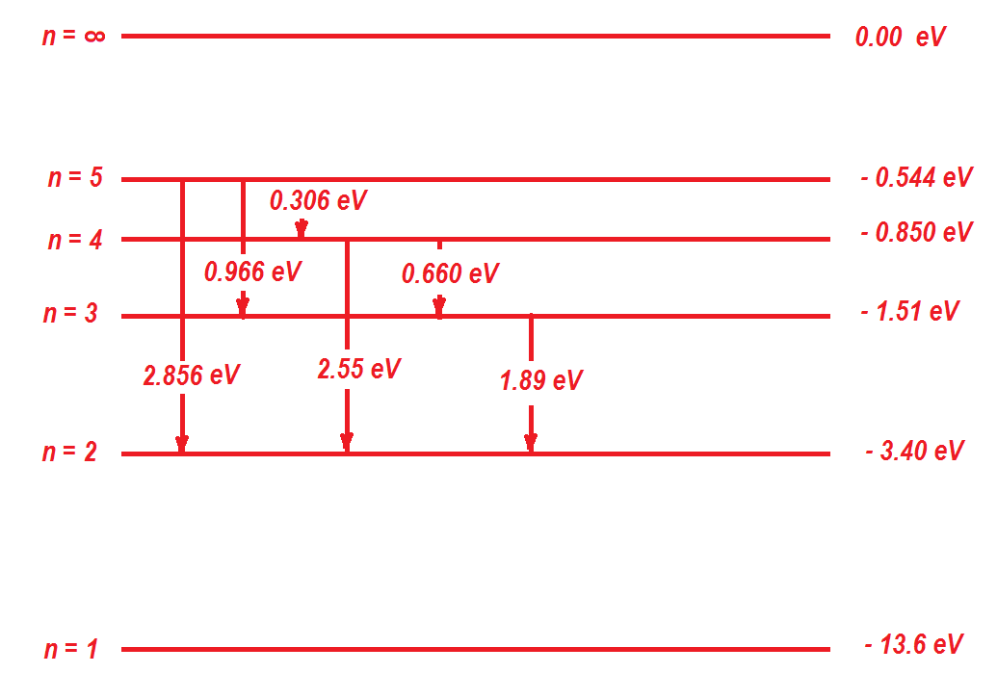b) Assuming that hydrogen atoms on Saturn are excited with the ground state electrons transitioning to level n=5, list all the possible photon wavelengths that can be emitted when the electrons downward transition to level n = 2 as they de-excite. Show all working to obtain full marks. [6]

***All possible downward transitions from level n = 5 down to level n = 2 are shown above.  
Photon emitted with highest energy = 2.856 eV = 2.856 × 1.6 × 10−19= 4.5696 × 10−19J.  
Wavelength is $=\frac{hc}{E}= \frac{6.63 10^{-34} 3 10^{8}}{4.5696 10^{-19}}=4.3526 10^{-7}m=435.26 nm$  
All other emitted photons have less energy thus will have wavelengths longer than this.***

$${}_{2.55eV}=435.26 \frac{2.856}{2.55}=497.4912 nm \\ {}_{1.89eV}=435.26 \frac{2.856}{1.89}=657.7262 nm \\ {}_{0.966eV}=435.26 \frac{2.856}{0.966}=1286.856 nm \\ {}_{0.660eV}=435.26 \frac{2.856}{0.660}=1883.489 nm \\ {}_{.306eV}=435.26 \frac{2.856}{0.306}=4062.427 nm$$

***The emitted wavelengths are; 497 nm; 658 nm; 1290 nm; 1880 nm; 4060 nm***

c) What is the minimum energy of a proton from the solar wind that can excite a hydrogen atom from ground state to the level n = 5? [3]

What will be the de Broglie wavelength of that proton? [3]

***E = 13.6 − 0.544 = 13.056 eV = 13.056 × 1.6 × 10−19 J = 2.08896 × 10−18 J ***

**END OF TASK 7**